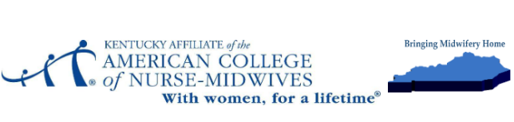
Kentucky Affiliate of the American College of Nurse-Midwives
March 15, 2024
Notice of Scholarship Availability
Dear Students,
The Kentucky Affiliate of A.C.N.M. is pleased to announce the availability of two scholarships for the 2024 academic year. The goal of these scholarships is to support deserving Kentucky nurse-midwifery students in pursuit of their educational goals and to foster the growth of nurse-midwifery in the Commonwealth. Applications will be accepted until April 15, 2024.
Scholarship Details:
- Two scholarships are available, each for $1,000.
- Eligibility criteria:
  - A nurse-midwifery student who currently resides in Kentucky and has completed at least one continuous year of an accredited nurse-midwifery education program and is currently enrolled and in good standing.
  - A current member of A.C.N.M.
  - Upon graduating and passing the AMCB certification examination has the goal of practicing as a CNM in Kentucky.
- Requirements:
  - Application form
  - Academic transcripts
  - A letter from a school official documenting continuous enrollment in an accredited nurse-midwifery program
  - Verification of Kentucky residency (copy of current Ky driver’s license)
  - Current resume
  - 300-500 word essay discussing such issues as initiative, leadership goals, involvement in professional organizations, and/or commitment to rural and underserved populations, and plans for providing nurse-midwifery services in Kentucky.
The Kentucky Affiliate of A.C.N.M believes in empowering Kentucky nurse-midwifery students to achieve their full potential, and these scholarships are a testament to our goal of increasing the availability of CNMs in the Commonwealth. We value traits such as participation in our state affiliate, state and national midwifery advocacy, and support for maternal health with attention to addressing health disparities.
For more information, please email kyaffiliateofacnm@gmail.com.
Sincerely,
Dolores (Dee) Polito, DNP, CNM, FACNM
President, Kentucky Affiliate of A.C.N.M

